

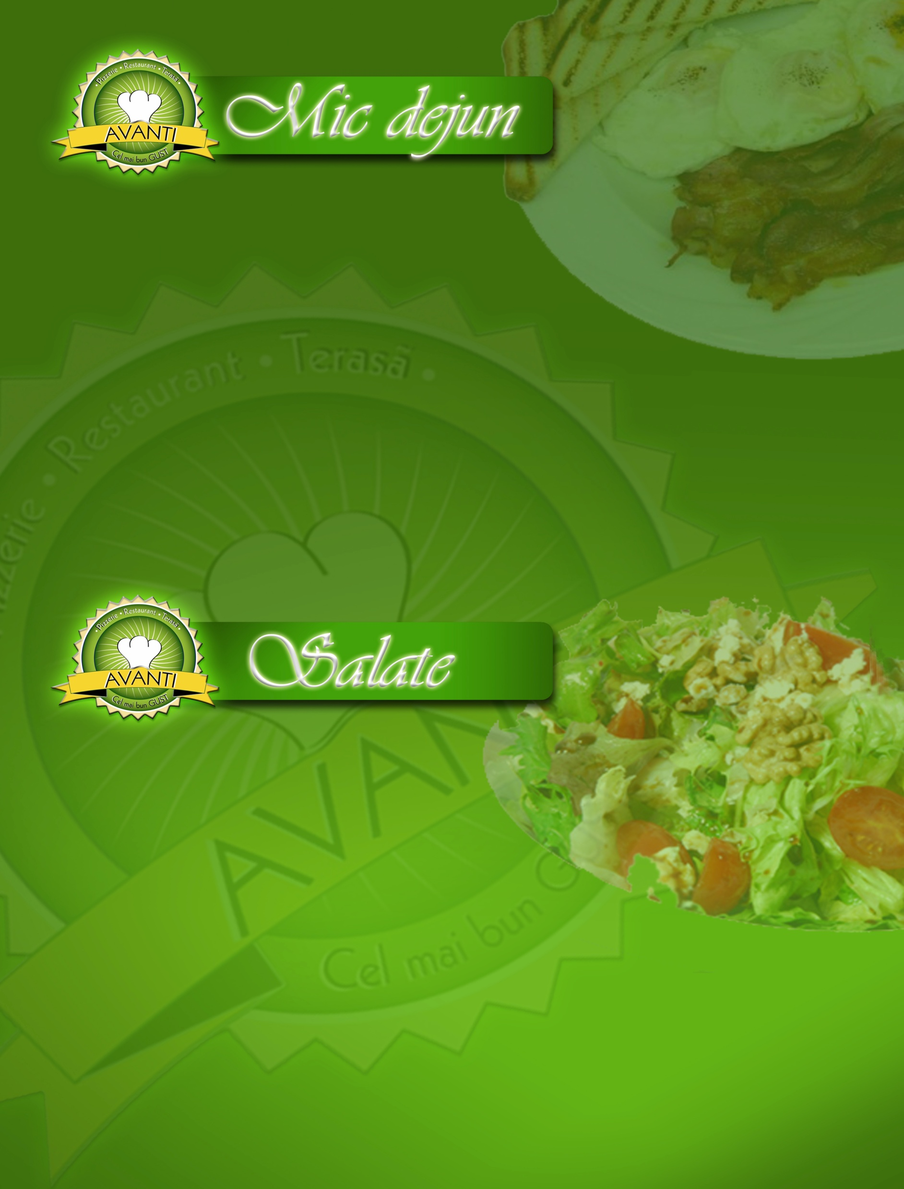

Omleta Mixta.................................................................5,00 lei
(2oua, cascaval, ceapa, sunca) …240 g

Omleta Primavera..........................................................4,00 lei
(2 oua, ardei, rosii, ceapa)….........230 g

Omleta Simpla................................................................3,50 lei
(2 oua, cascaval)……………… 140 g

Ochiuri ..............................................................................3,50 lei
(2 oua, cascaval) …………...… 150 g

Salata Puisor...................................................................11,90 lei
(piept pui, sunca, ou fiert, varza, ardei, rosii, sos maioneza cu smantana, sare)...........................520 g

Salata Bulgareasca.......................................................10,90 lei
(varza, rosii, ardei, telemea, sunca, masline, castraveti, ou, ulei, otet, sare)...................................................... 560 g

Salata cu piept de pui..............................................10,90 lei
(piept pui, varza, ardei, rosii, castraveti, masline, ulei, otet, sare).........................................................510 g

Salata Delicioasa…..…………………………10,90 lei
(piept pui, telemea, rosii, porumb, masline, morcov, ceapa)………460 g

Salata Taraneasca……………..…..…………10,90 lei
(piept pui, cartofi fierti, telemea, ou, masline, usturoi, maioneza…430 g

Salata Pollo………............................…………..10,90 lei
(piept pui, sunca, ardei, porumb, varza, morcov, sos maioneza).....430 g

Salata Bianco ………………………………11,00 lei
(piept pui, sunca, cascaval, rosii, morcov, varza, maioneza….…..460 g

Salata Italiana….…………………...………10,90 lei
(piept pui, parmezan, rosii, castraveti,
ardei, porumb, smantana) ………460 g

Salata de ton..............................................................10,90 lei
(ton conserva, rosii, masline, morcovi,
varza, ardei, lamaie, sare, piper).... 600 g

Salata Mediterana .................................................10,90 lei
(ton conserva, porumb, masline, varza,
ceapa, rosii, lamaie, sare )...................500 g

Salata Romaneasca….............................……..11,90 lei
(piept pui la gratar, telemea, rosii,
castraveti, varza, ceapa, ou fiert)....570 g
Pofta buna!



PIZZA AVANTI
(mozzarella, şunca presata, costita, cabanos, ciuperci, masline, oregano)
MEDIE 581 g.........................................12,40 lei
MARE 812 g........................................ 15,00 lei
GIGANT 1514 g………..…………………..………34,00 lei

PIZZA VENEZIANA
( mozzarella, piept de pui, costita, ardei gras, oregano)
MEDIE 511 g......................................... 12,40 lei
MARE 682 g.........................................14,90 lei
GIGANT 1404 g……….……………………..……..34,00 lei

PIZZA CAPRICCIOSA
( mozzarella, şuncă presată, ciuperci, măsline, salam, ceapă, oregano)
MEDIE 581 g........................................... 12,40 lei
MARE 822 g..........................................14,90 lei
GIGANT 1424 g………………………….………….34,00 lei

PIZZA CAMPAGNOLA
(mozzarella, piept de pui, ardei gras, ceapă, oregano)
MEDIE 451 g..............................................12.00 lei
MARE 622 g..............................................14,50 lei
Gigant ………………………………….. …….34,00 lei
Pofta buna!


PIZZA QUATTRO FORMAGGI
(mozzarella, gorgonzola, parmesan, caşcaval)
MEDIE 410 g............................................. 12,40 lei
MARE 580 g..............................................15,00 lei
Gigant ………………………………….. …….34,00 lei

PIZZA GIAN CARLO
(mozzarella, piept pui, salam, porumb, oregano)
MEDIE 501 g................................................12,40 lei MARE 682 g...............................................14,90 lei Gigant 1414 g…………………………….……...……..34,00 lei

PIZZA CLAUDIU
(mozzarella, şuncă presată, ciuperci, porumb boabe, oregano)
MEDIE 481 g...............................................12,00 lei
MARE 662 g…………………………….………..……..14,50 lei
Gigant …………………………………………….34,00 lei

PIZZA INCAZZATA
(mozzarella, salam , ardei iute, oregano) MEDIE 392 g...............................................12,00 lei MARE 534 g .............................................14,50 lei
Gigant …………………………………………….34,00 lei

PIZZA TONNO
( mozzarella, ton, ceapă, oregano) MEDIE 439 g...............................................12,40 lei MARE 592 g................................................14,90 lei
Gigant ……………………………………… …..34,00 lei
Pofta buna!


PIZZA QUATTRO STAGIONI
(mozzarella, şuncă presată, ciuperci, măsline, salam, oregano)
MEDIE 501 g.............................................. 12,40 lei
MARE 702 g...............................................14, 90 lei
Gigant ……………… ……………………. ……34,00 lei

PIZZA CALZONE SPECIALE

( mozzarella, şuncă presată, ardei gras, roşii, ciuperci, măsline, parmesan, ulei de măsline) MEDIE 550 g.................................................12,40 lei MARE 790 g.................................................15,00 lei

PIZZA VEGETARIANA

(sos roşii, ardei gras, ciuperci, măsline, roşii, porumb boabe, oregano) MEDIE 481 g ....................................................12,00 lei MARE 672 g....................................................14, 50 lei

Gigant ………………………………….. ….34,00 lei

PIZZA MARGHERITA
(mozzarella, sos roşii, oregano) MEDIE 331 g ......................................................10,50 lei MARE 452 g......................................................14,00 lei
Pota buna!

Gigant ………………………………………. …….34,00 lei



PIZZA BOLOGNESE
(mozzarella, salam, cabanos, masline, oregano) MEDIE 431 g…………………............................. 12,00 lei MARE 592 g.................................................14,50 lei
Gigant ………………………….. 34,00 lei

PIZZA POLLO

(mozzarella, piept pui, ciuperci, ardei, masline)

MARE 702 g…………………………..……………….14,90 lei

MEDIE 491 g……………………………….…………..12,40 lei

Gigant …………………………………. ………34,00 lei

PIZZA NAPOLI

(mozzarella, sunca, piept, salam, masline, oregano)

MARE 732 g……………………………..……………14,90 lei

MEDIE 521 g……………………………..…………....12,40 lei

Gigant ……………………………………….….34,00 lei

PIZZA CAPONE

(mozzarella, salam,rosii, ardei, masline, oregano)

MARE 720 g……………………………….……….…14,90 lei

MEDIE 511 g……………………………………………12,40 lei
Pofta buna!

Gigant ………………………………………….34,00 lei

PIZZA DOMNEASCA

(mozzarella, piept, salam, ciuperci, rosii, oregano)

MARE 720 g……………………………..……………14,90 lei

MEDIE 580 g……………………………..…………....12,40 lei

Gigant ……………………………………….….34,00 lei

PIZZA TOSCANA

(mozzarella, sunca, piept pui, ardei, porumb, oregano)

MARE 682 g……………………………..…………….14,90 lei

MEDIE 491 g…………………………………..…………12,40lei

Gigant ……………………………………..……34,00 lei

PIZZA PREGO

(mozzarella, costita, sunca, ciuperci, oregano)

MARE 652 g……..…………………………….………14,90 lei

MEDIE 461 g…………….……………………..….…..12,40 lei

Gigant ……………………………………….…34,00 lei

PIZZA VERONA

(mozzarella, sunca, piept, masline, ciuperci, oregano)

MARE 712 g………………………………….…………..14,90 lei

MEDIE 501 g…………………………………….….……12,40 lei

Gigant ………………………………. ………….34,00 lei

PIZZA CHICKEN

(mozzarella, piept pui,costita,ciuperci, masline, oregano)
MEDIE 570 g.........................................12,40 lei
MARE 830 g........................................ 14,90 lei
GIGANT ………..…………………..………34,00 lei

PIZZA COUNTRY
( mozzarella,piept pui, sunca, masline, porumb, oregano)
MEDIE 610 g......................................... 12,40 lei
MARE 840 g..........................................14,90 lei
GIGANT ……….……………………..……..34,00 lei

PIZZA RUSTICA
( mozzarella, piept pui,salam, ardei, ceapa, oregano)
MEDIE 580 g........................................... 12,40 lei
MARE 800 g............................................14,90 lei
GIGANT …………….…………….………….34,00 lei

PIZZA PROSCIUTO E FUNGHI
(mozzarella,sunca, ciuperci, oregano)
MEDIE 451 g.............................................12,00 lei
MARE 622 g.............................................14,50 lei
GIGANT ………………………….………….34,00 lei

PIZZA HAWAI
(mozzarella,piept pui, ananas, oregano)
MEDIE 451 g.............................................12,40 lei
MARE 622 g.............................................14,90 lei
GIGANT ………………………….………….34,00 lei
Pofta buna!

Pizza pentru copii

Pizza Anastasia.........................12,40 lei
(mozzarella, piept pui, ardei,porumb, rosii, oregano)..........451 g

Pizza Strunfi...............................12,40 lei
(mozzarella, sunca, rosii, masline, oregano)…......................421 g

Pizza Prichindel.........................12,40 lei
(mozzarella, cabanos, costita, rosii, oregano)..........................431 g

Sos pizza(100 g)

Sos de rosii dulce......................................................1,50 lei

Sos de rosii picant....................................................1,50 lei

Sos de maioneza.......................................................1,50 lei

Sos de usturoi ..........................................................2,00 lei

Sos smantana cu usturoi….....…………...…2,00 lei

Shaorma la farfurie………………….…. 12,00lei

(piept pui, cartofi pai, salata, maioneza, focacia),- 750 g

Pofta buna!

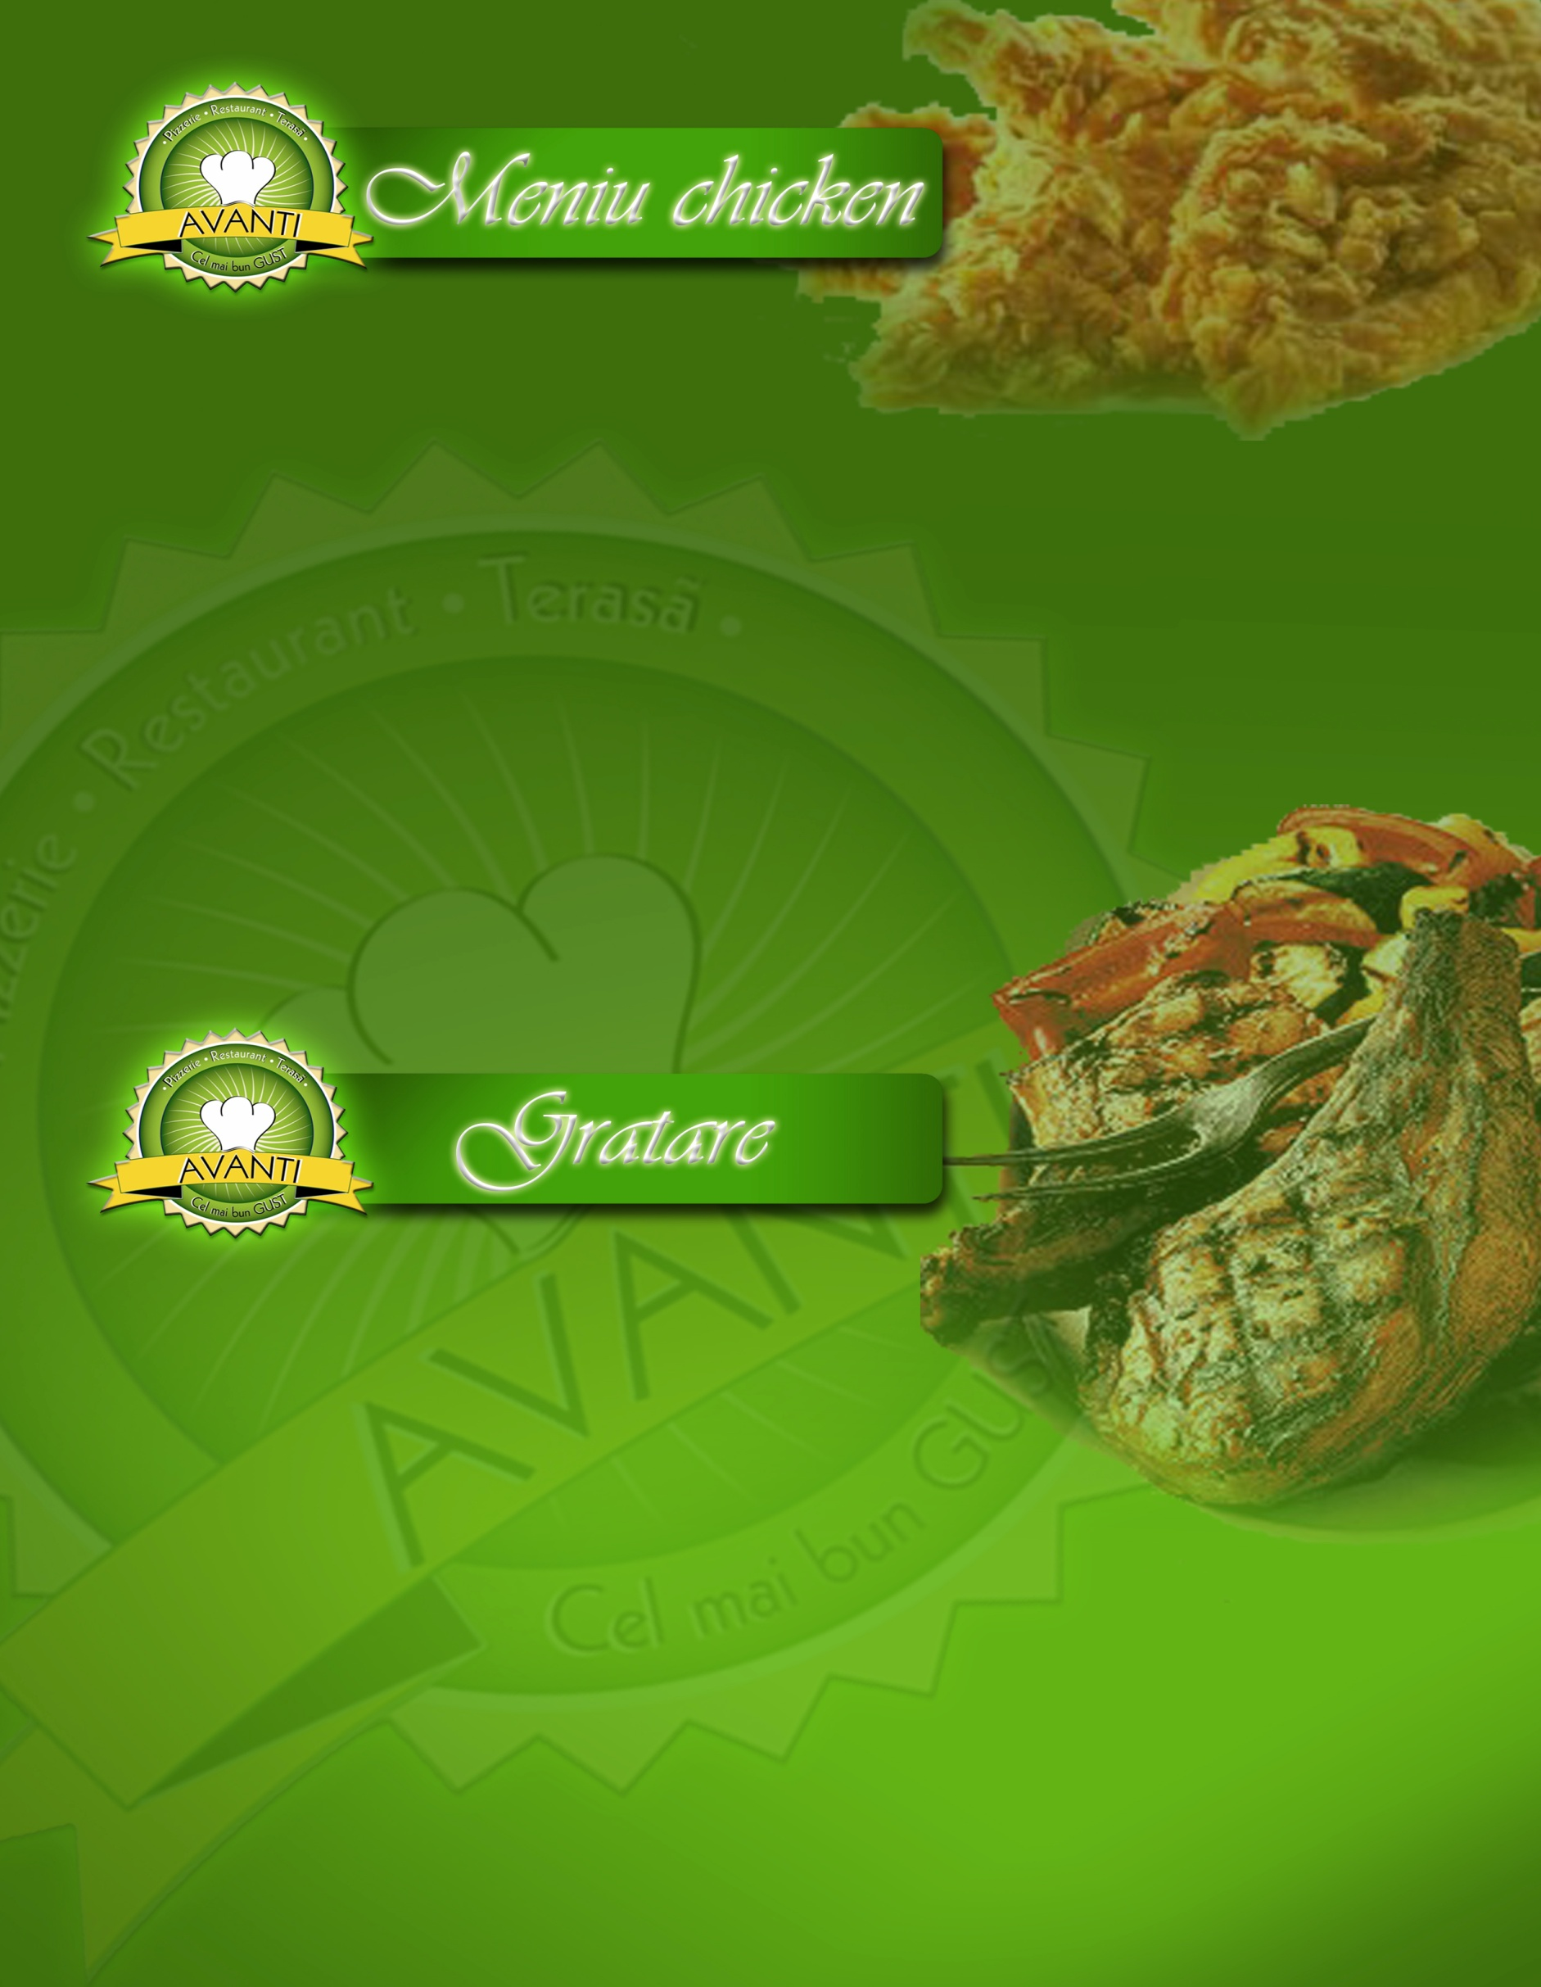

Aripioare crispy
6 bucati, cartofi pai, sos usturoi 600 g…………………13,50 lei
8 bucati, cartofi pai, sos usturoi 700 g………….……...16,50 lei

Fasii crispy
Meniu 5 bucati piept, cartofi pai, sos usturoi 450 g……13,50 lei
Meniu 8 bucati piept,cartofi pai, sos usturoi 500 g……16,50 lei

Piept de pui la gratar--150g......................................................8,00 lei

Snitel parizian din piept de pui 250g..................................9,00 lei

Snitel crocant…….......................................................................10,00 lei
(piept pui, fulgi, ou.......................250 g)



Cartofi natur…………..………….…….....…...3,00 lei

(cartofi, margarina,sare)....300 g

Cartofi piure..................300g……….…….............3,00 lei

Cartofi pai…......................300g....................................3,00 lei

Salate

Salata de varza.................................150 g…….2,00 lei

Salata de varza cu rosii …...…..200 g…….3,00 lei

Salata de rosii……........................200 g……..4,00 lei

Salata moldoveneasca…....…............................4,50 lei

(rosii, telemea)……………...300 g

Salata asortata ………..…......…..………..4,50 lei

(rosii, castraveti, varza, ardei)

Focaccia .............200 g......................2,50 lei

Desert
Clatite cu: finetti …………………..……….....4,50 lei
gem capsuni………………………4,50 lei

gem caise………………………….4,50 lei

